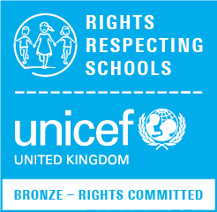
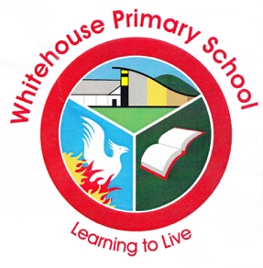

Dear Parents/Carers,

We are very pleased to tell you that we have recently been awarded the first stage of Unicef UK’s Rights Respecting Schools Award (RRSA), Bronze: Rights Committed.
We are always striving to create the best possible learning environment for our children and this achievement shows that we are committed to promoting and realising children’s rights and encouraging adults, children and young people to respect the rights of others in school.
We have set up a pupil-led steering group and have an action plan to ensure that:
- The United Nations Convention on the Rights of the Child (CRC) underpins our values and decision making in school
- The whole school learns about the CRC and respects the rights of others
- Children are empowered to become active learners and active local and global citizens.
Unicef (United Nations Children’s Fund) is the world’s leading organisation working for children and their rights, and we will be joining a community of over 4,500 schools in the UK working on the Rights Respecting Schools Award.
Right Respecting Schools across the country have reported that that the Award has many positive impacts including improved relationships, wellbeing and self-esteem, leading to better attendance and improved learning.
You can find out more about Unicef, the United Nations Convention on the Rights of the Child and the Rights Respecting Schools Award from the RRSA website:
www.unicef.org.uk/rrsa
We will be using the RRSA logo on our letters and will keep you informed about our rights respecting journey through our website, newsletters and events.
If you would like to find out more or be part of the RRSA Steering Group please contact Miss Campbell (Year 6) by email – jcampbell923@c2kni.net.
We appreciate your support as we continue to move forward with this award.

F. Bailie
Principal

